

**WELCOME**

**Welcome**

Welcome! Thank you again for choosing to stay with us. In this guide, you will have all of the important information for your stay. If something is not here, please text/call me anytime!

**PHONE #:** (222) 333 - 4444

**EMAIL:** email@email.com

**PROPERTY ADDRESS:** 12345 Awesome Lane #A, Small Town WA 12345

**DIRECTIONS:** Add any special directions if not easy to find with address

**PARKING:** Add instructions if parking is not obvious and on property



**WIFI**

**Welcome**

**NETWORK:** WIFI_NETWORK_NAME

**PASSWORD:** WIFI_NETWORK_PASSWORD



**EMERGENCY INFO**

**EMERGENCY #: 911**

For any life-threatening emergency, please dial “911” for police, fire, or medical aide.

**FIRST AID LOCATION:**

In the kitchen, in the right drawer below the microwave and above the dishwasher.

**FIRE EXTINGUISHER:**

In the kitchen below the kitchen sink.

**NEAREST HOSPITAL:**

Address: Phone:

**FIRE DEPARTMENT:**

Address: Phone:

**POLICE PRECINCT:**

Address: Phone:

**HOUSE RULES**

**Welcome**



A friendly reminder of the house rules you agreed to when you booked through Airbnb. ☺ Thank you in advance for respecting them.

**HOUSE RULES:**

* Quiet hours from 9pm – 8am every day
* Max occupancy is 4
* No pets allowed
* Parties are not allowed
* Locked shed in backyard is off-limits.

**NO SMOKING:**

Smoking is prohibited anywhere inside the unit or anywhere on the property. You may smoke on the street in front of the gate entrance. Any signs of smoking on premise or inside the house may subject the guest to a $250 clean-up fee.

**PUBLIC TRANSIT**

**Welcome**



**SUBWAY/METRO STATION:**

At the Northeast corner of Washington Blvd and Flower St. 5-minute walk. Mostly runs between 6am-10pm. Check latest schedules HERE.

**BUS STOP:**

At the Northeast corner of Washington Blvd and Flower St. 5-minute walk. Mostly runs between 6am-10pm. Check latest schedules HERE.



**RIDE SHARE**

**Welcome**

**UBER CODE:** ABCDE1

For first time Uber users, download the app with this code to get a credit towards your first ride.

**LYFT CODE:** ABCDE2

For first time LYFT users, download the app with this code to get a credit towards your first ride.

**KITCHEN**

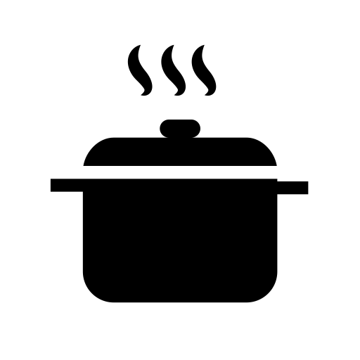

**OVEN:**

Burnt or caked on sauces or food may incur an additional cleaning fee so be sure to use foil, which is located in the drawer just left of the oven.

**MICROWAVE:**

Please use the microwave cover to avoid messes in the microwave.

**TRASH:**

If the trash gets too full during your stay, you can throw it into the large GREEN outside bins on the left side of the house behind the gate. Additional trash bags are below the sink.

**DISHWASHER:**

Please do not run the dishwasher until full.

**CLEANING SUPPLIES:**

In the kitchen below the kitchen sink.



**TV REMOTE**

**Welcome**

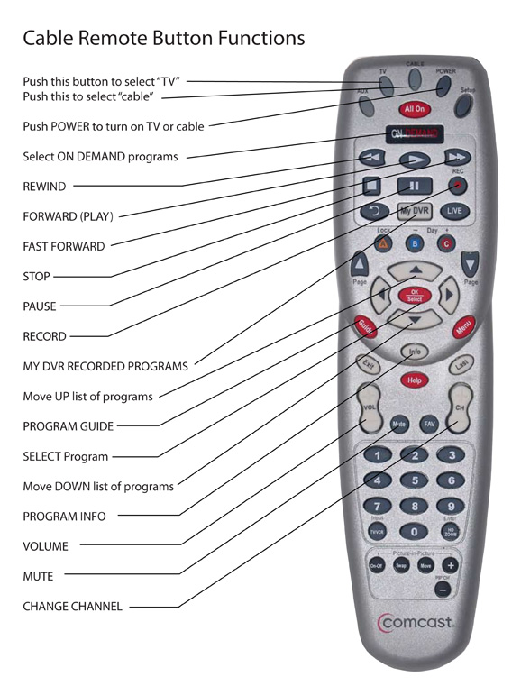

If you still have questions, you can watch [**this video**](https://www.youtube.com/watch?v=zSH1R2D-fAg) we posted on YouTube to show you how to turn everything on, including Netflix.

**HEATER/AIR CONDITIONER**

**Welcome**

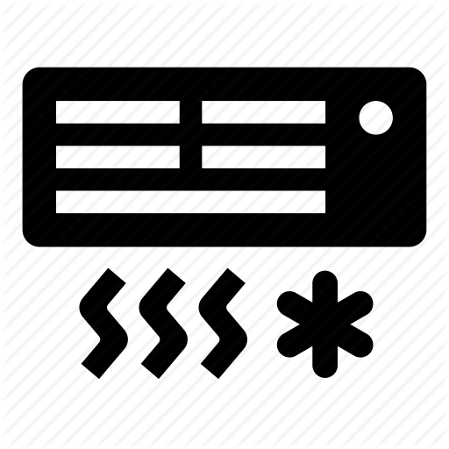

As an Airbnb, daily housecleaning services are not available. All linens (bed sheets, towels, pillow cases, etc.) are provided. You can find extras in the cabinet on the left side of the hallway.



**LINENS | TOWELS**

**Welcome**

As an Airbnb, daily housecleaning services are not available. All linens (bed sheets, towels, pillow cases, etc.…) are provided. You can find extras in the cabinet on the left side of the hallway.

**CHECKOUT INSTRUCTIONS**

**Welcome**



We hope you enjoyed your stay with us!

Please make a quick walk through and check the nightstand to make sure you’ve packed and gathered all of your belongings!

**CHECKOUT TIME:** 11AM

**KEYS:** Leave on the key hanger next to the bright orange keychain

We’re always looking to improve and would welcome any suggestions and feedback. Take our survey HERE.

We wish you safe travels!

Best, Your Host

**NEARBY EVENTS & ACTIVITIES**

**Welcome**



**January:**

* Movie on the Lawn @ Moorsfield Park every Saturday at 8pm. For details, click here.
* Chalk Art Festival (Jan 13 Saturday) on Main St & 2nd. For details, click here.

**February:**

* Movie on the Roof @ The RoofTop Theatre every Saturday at 8pm. For details, click here.
* Art Walk (Feb 16 Saturday) on Main St & 2nd. For details, click here.

**March:**

* A
* B
* C

**April:**

* A
* B
* C

**May:**

* A
* B
* C

**June:**

* A
* B
* C

**July:**

* A
* B
* C

**August:**

* A
* B
* C

**September:**

* A
* B
* C

**October:**

* A
* B
* C

**November:**

* A
* B
* C

**December:**

* A
* B
* C